Chapter 10, Solution 32.

Determine V_{o} and I_{o} in the circuit of Fig. 10.80 using mesh analysis.

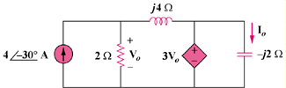

Figure 10.80
For Prob. 10.32.

Solution

Consider the circuit below.

j4

3 V_{o}

-j2

4-30 V

2

+

V_{o}

+

I₂

I₁

I_{o}
For mesh 1,
where

Hence,
or

8.48515 A

5.657-75 V

